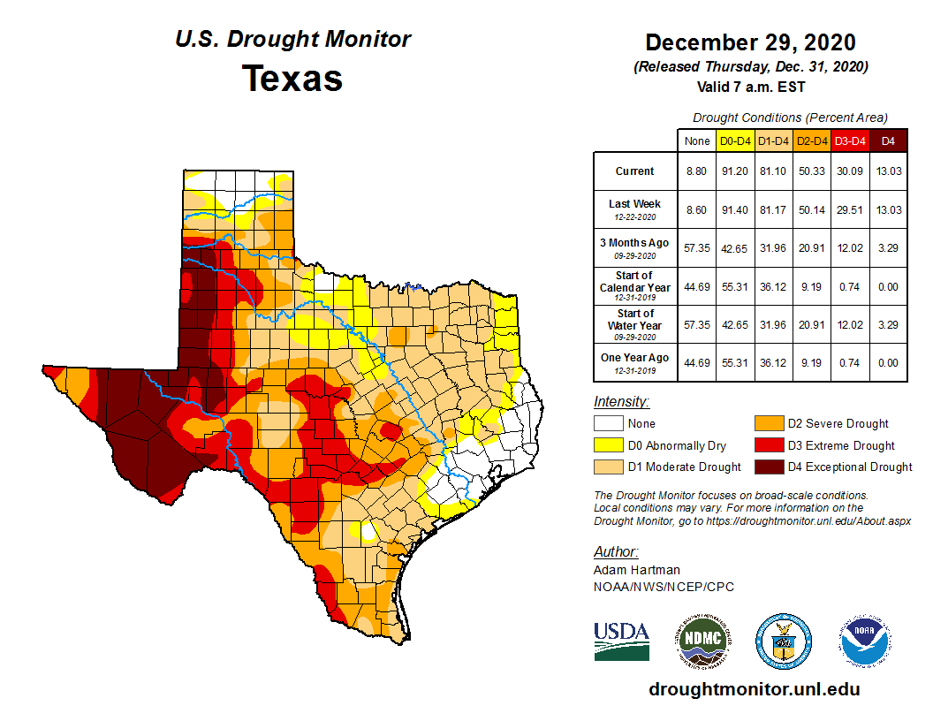

South
Most of the precipitation fell on the eastern third of the Southern Region associated with a frontal boundary during Wednesday and Thursday (Dec. 23-24). This led to some minor trimming of D0 in south-central Tennessee and extreme northwestern Alabama which received 1.5 to 2 inches of rain. However, locations along and west of the Mississippi River observed below-normal weekly totals, warranting further expansion of D0 in eastern and northern Arkansas. Some slight improvement (D1 to D0) and removal (D0) north of Houston was also justified in localized areas that received more than 1.5 inches of rainfall. Light precipitation fell over parts of Oklahoma and Texas Monday into Tuesday (Dec. 28-29) as energy exiting the southern Rockies and intensified across the Central and Southern Plains. Despite the late arrival of the system in the Plains this week, the previous week’s release of the Drought Monitor remained representative of conditions across Oklahoma and most of Texas. However, southern Texas saw some slight degradation along the Lower Rio Grande Valley, with D3 expanded northward from Starr County to Webb County, and D2 expansion southward into southeastern Hidalgo and western Cameron Counties. This region has experienced low relative humidity and topsoil moisture. NASA SPoRT soil moisture data depicts the top 10 cm of soil below the 2nd percentile in areas where D3 was expanded, and between the 5th and 10th percentiles where D2 was expanded. NASA GRACE ground water data and the National Land Data Assimilation System (NLDAS) also support this deterioration.

