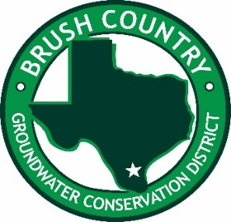
732 W. Rice
Falfurrias, Texas 78355
361-325-5093
gcdaa@brushcountrygcd.com
or
lpena@brushcountrygcd.com
Seminar/Training
Agenda
Friday, July 23rd,2021
9:00 AM-9:15 Welcome & Introduction Luis “Louie” Pena General Manager Brush Country Groundwater Conservation District
9:15 AM-10:15 Administrative Rules of the Texas Department of Licensing and Regulations - Adam Foster Texas Department of Licensing and Regulations (TDLR)
10:15AM-10:30 Break
10:30AM-12:00 Pressure Cementing Water Wells – Josh Cummings, Consultant with Halliburton
12:00 PM-1:00 PM Lunch
1:00 PM-1:30 PM Brush Country Groundwater Conservation District Plugging Program- Luis “Louie” Pena General Manager Brush Country GCD
1:30PM-1:45 PM GCD Responsibilities Andy Garza Kenedy County GCD
1:45PM-2:00 PM Break
2:00 PM-2:15 PM Communication between Groundwater Conservation District’s and Water Well Contractors-Felix Saenz Brush Country GCD Consultant
2:15 PM-3:15 PM Texas Occupations Code/Closing-Legal Counsel Bill Dugat

7

